<HUB> accounts payable – Duplicate invoice records



CONTENTS
1 CREATE A WISE ACCOUNT 2
2 Get your US account details 3

CREATE A WISE ACCOUNT
Creating a Wise account allows ZTERS team members to receive payments in US dollars easily and legally. Wise provides a USD account with local banking details, enabling fast, low-fee international transfers and simple conversion to your local currency when needed.
- Go to https://wise.com/
- Select Sign Up in the upper-right corner of the page.
- Enter your email address and click Next. You could also sign up using your Google, Facebook, or Apple account.
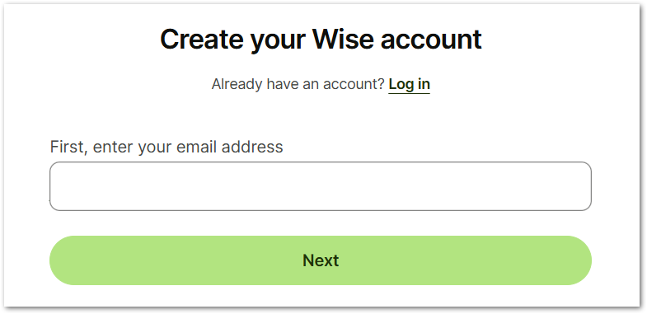
- Check your email and confirm the email address. Once it’s confirmed, you will be redirected to continue setting up your Wise account.

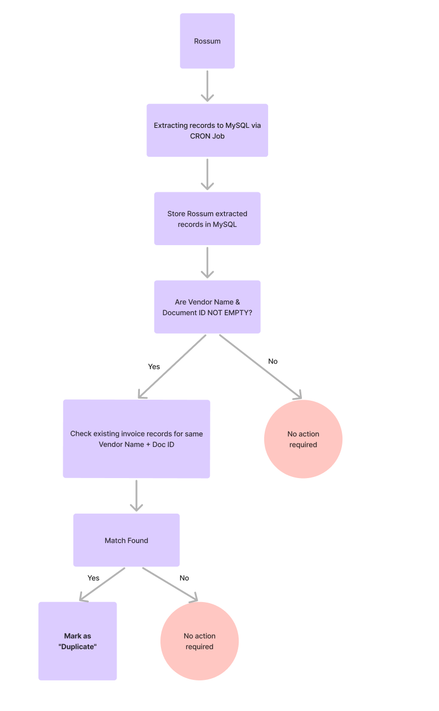

Get your US account details
Once your Wise account is set up, you can generate your USD account details directly from the platform. These details (bank name, routing number, and account number) must be shared with ZTERS to receive payments as if you had a local US bank account, with full transparency and low fees.
- In your WISE home page, select Account details.
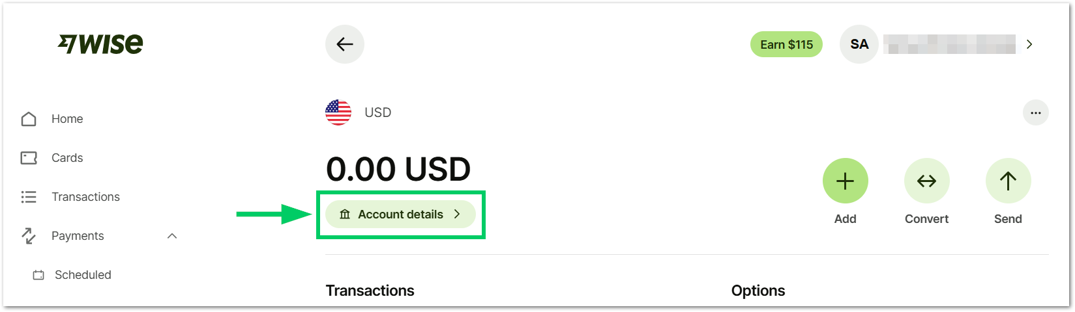
- To get your account details, you will need to add 20 USD to your WISE account. This amount is refundable and required only for verification purposes. Select Continue.
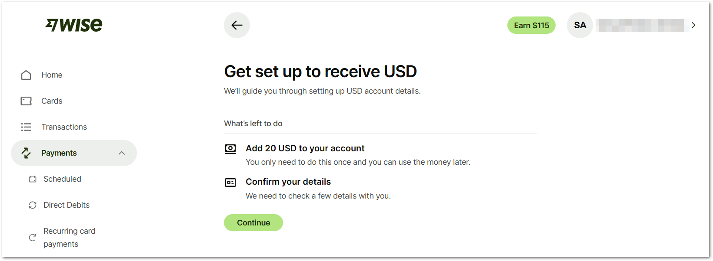
- You can select the way to add 20 dollars into your account. The following fees and processing times may vary depending on your country and payment provider:
Method | Fee | Transaction Time
Debit card | 0.25 USD | Seconds
Credit card | 1.31 USD | Seconds
Connected bank account (ACH) | 0.03 USD | Depending on the bank
Wire transfer | 6.11 USD | 1 day
International wire | 6.11 USD | 7 days

Tip: Both the Debit card and Credit card methods are recommended if you’re outside of the USA.

--- END OF THE DOCUMENT ---

